**Report**

**on**

**FRONT-END ENGINEERING**

**CS186**

by

**Anshuman Sharma**

**2110990222**

**G5**

**3rd YEAR**

**INSTRUCTOR’S NAME – MR. LAVISH ARORA**

**Batch 2021**

**Session 2023-24**



My project is based on an E-COMMERCE website for selling Electronics items online and deliver them to any part of the country. The title for the website is ”THEZ”. It took around 50 days for me to complete the project. The wesbsite has around 20 pages. The website is made with the idea that Electronic items are necessary nowadays and we are not targeting any specific audience or age group as these things can be useful to anyone but in Tier-2 and Tier-3 cities or rural areas it is difficult to find electronic shops that have or premium electronics items. So this website could be great experience for the buyers in buying products easily and at best prices. The most challenging parts of the website have been the header and the home page for me as I wanted to have the best design and structure possible, so I browsed the internet to search for different ideas and came up with a yellow and white theme which I think is simple but attractive.

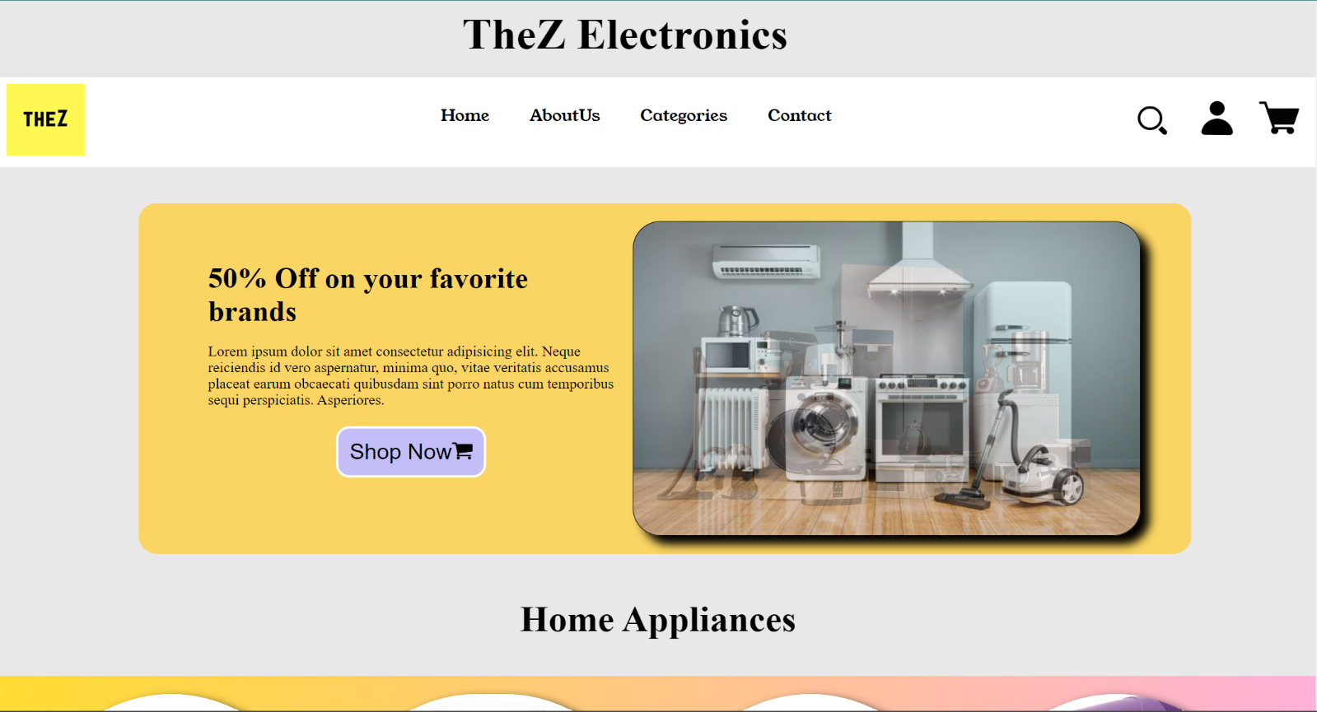

The page shown above is the **HOME PAGE** of the website, you can see the Logo of the website which says “THEZ” i.e also the title of the website. The website has been given a yellow and white theme.

On the top the user can see the **NAVIGATION PANEL** i.e the header, which is helpful in browsing throughout different pages in the website.

There are different options available on the navigation panel like “LOGIN”, “HOME”, “CATEGORIES”, “CONTANCT US”, “ABOUT US”, “THE SEARCH BAR”, “CART”, ”SIGN IN ” etc.

The **CATEGORIES** option is drop down menu which can navigate the user to pages such as the Smart Phones, the Laptop section ,Television section ,Smart Watch, Headphones. Also there is a search bar, so that the user can easily search the desired product by just selecting the name.

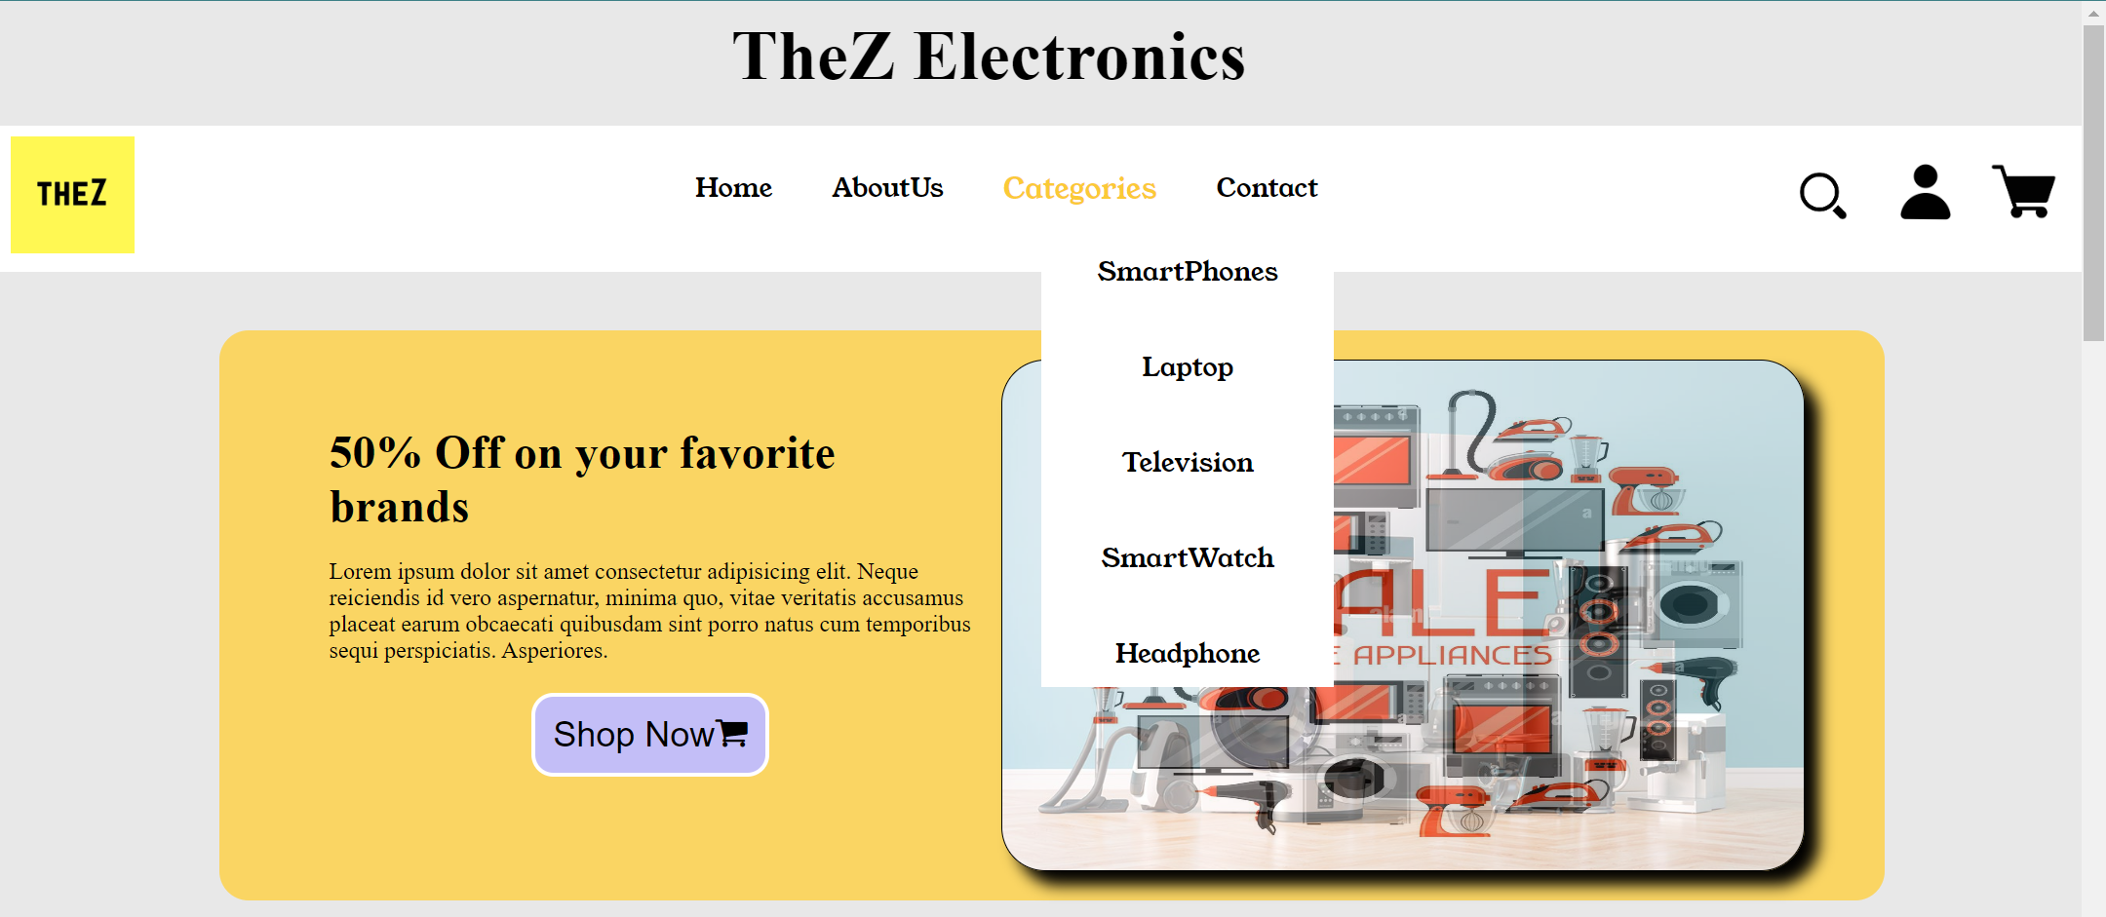

After the navigation panel, Comes the **Home appliances** section. These products are ones which are indeed needed in home for works like freezing, Washing, Cooling, etc.

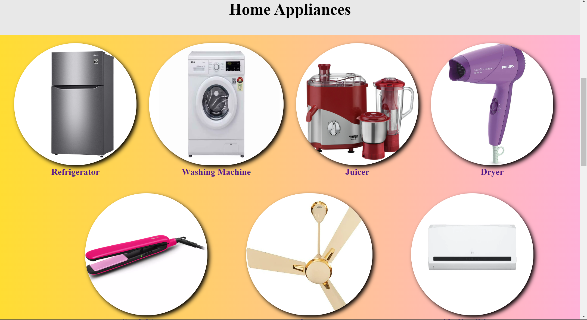

Then comes the **Electroics And Accessories** section of the Home page. Where products are related to work and luxury like Smart Phones , Laptop ,Head phones, Television, Neck-Band, Smart Watch.

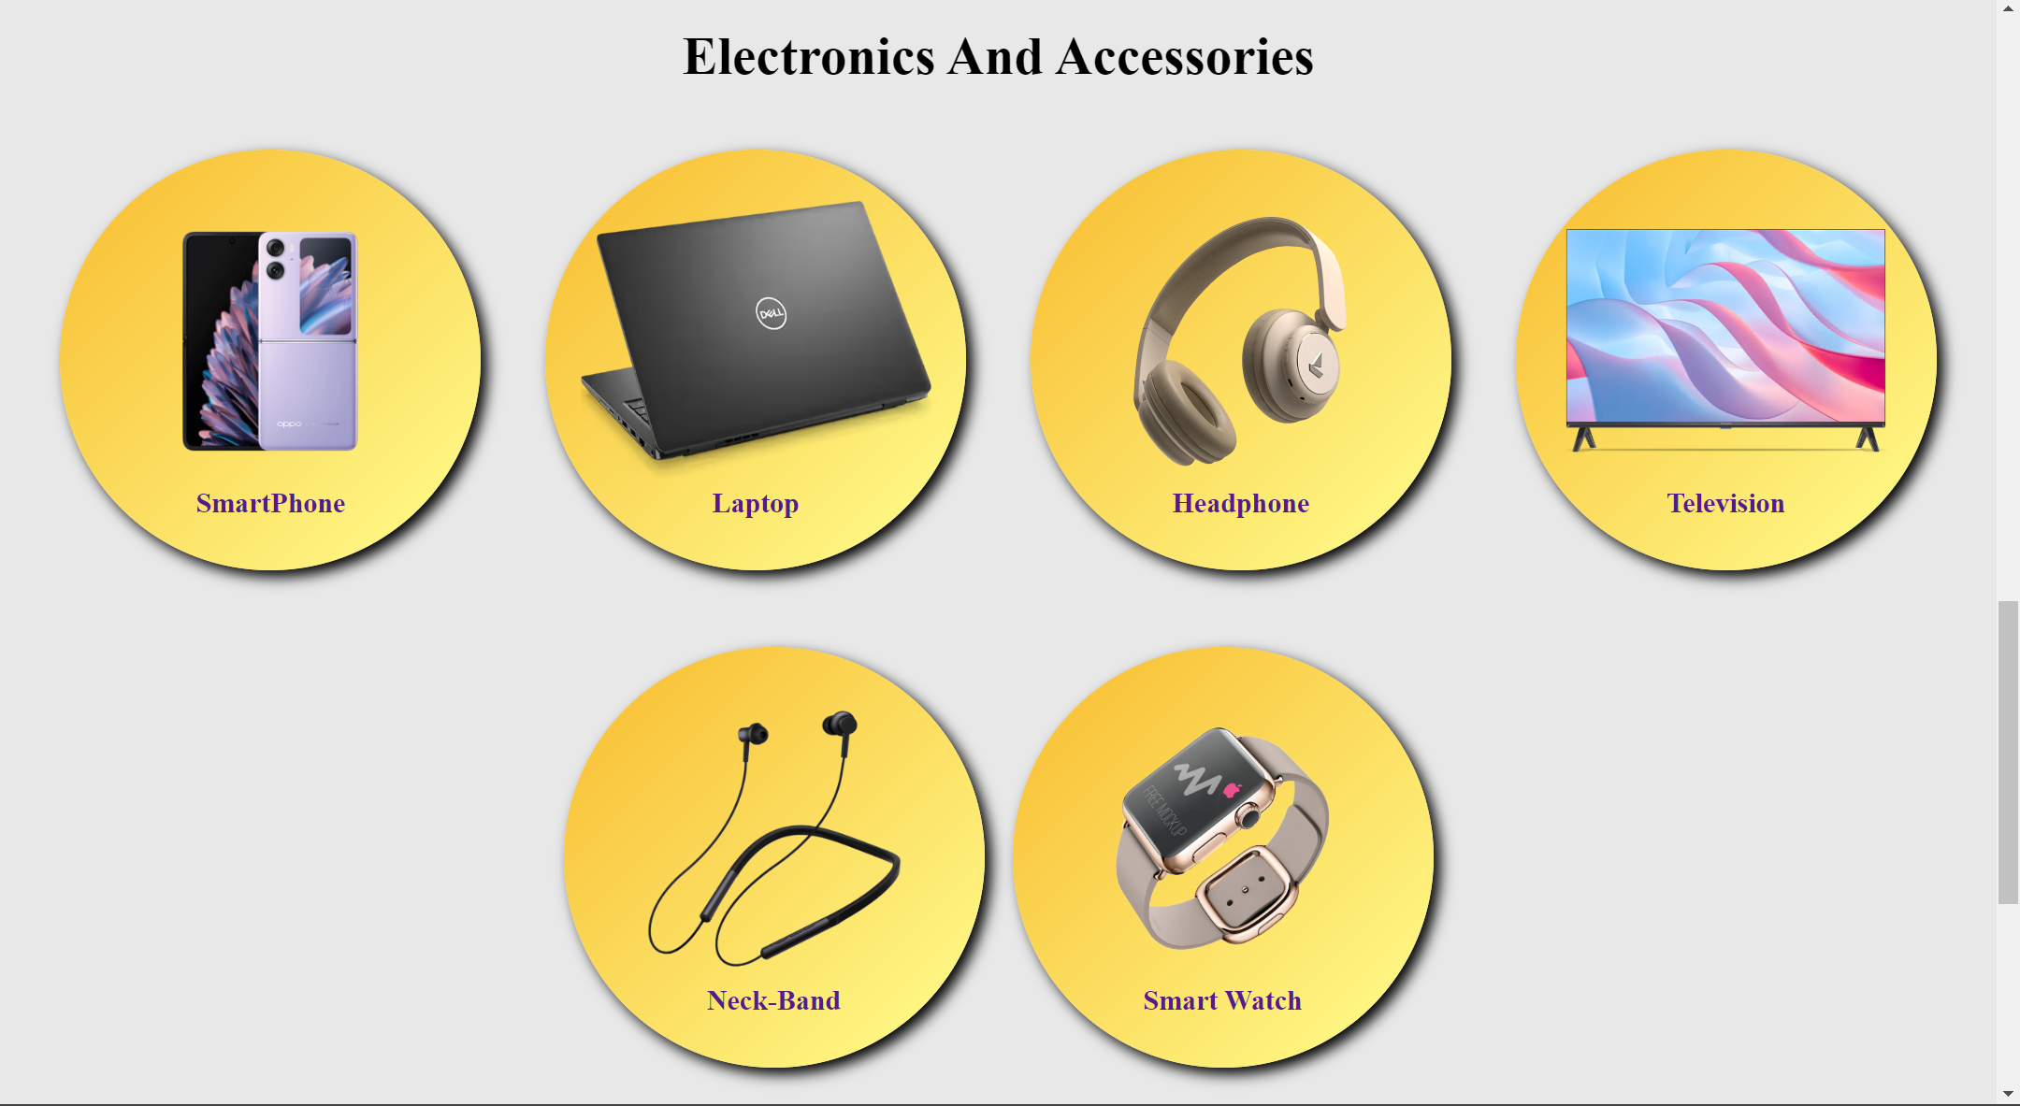

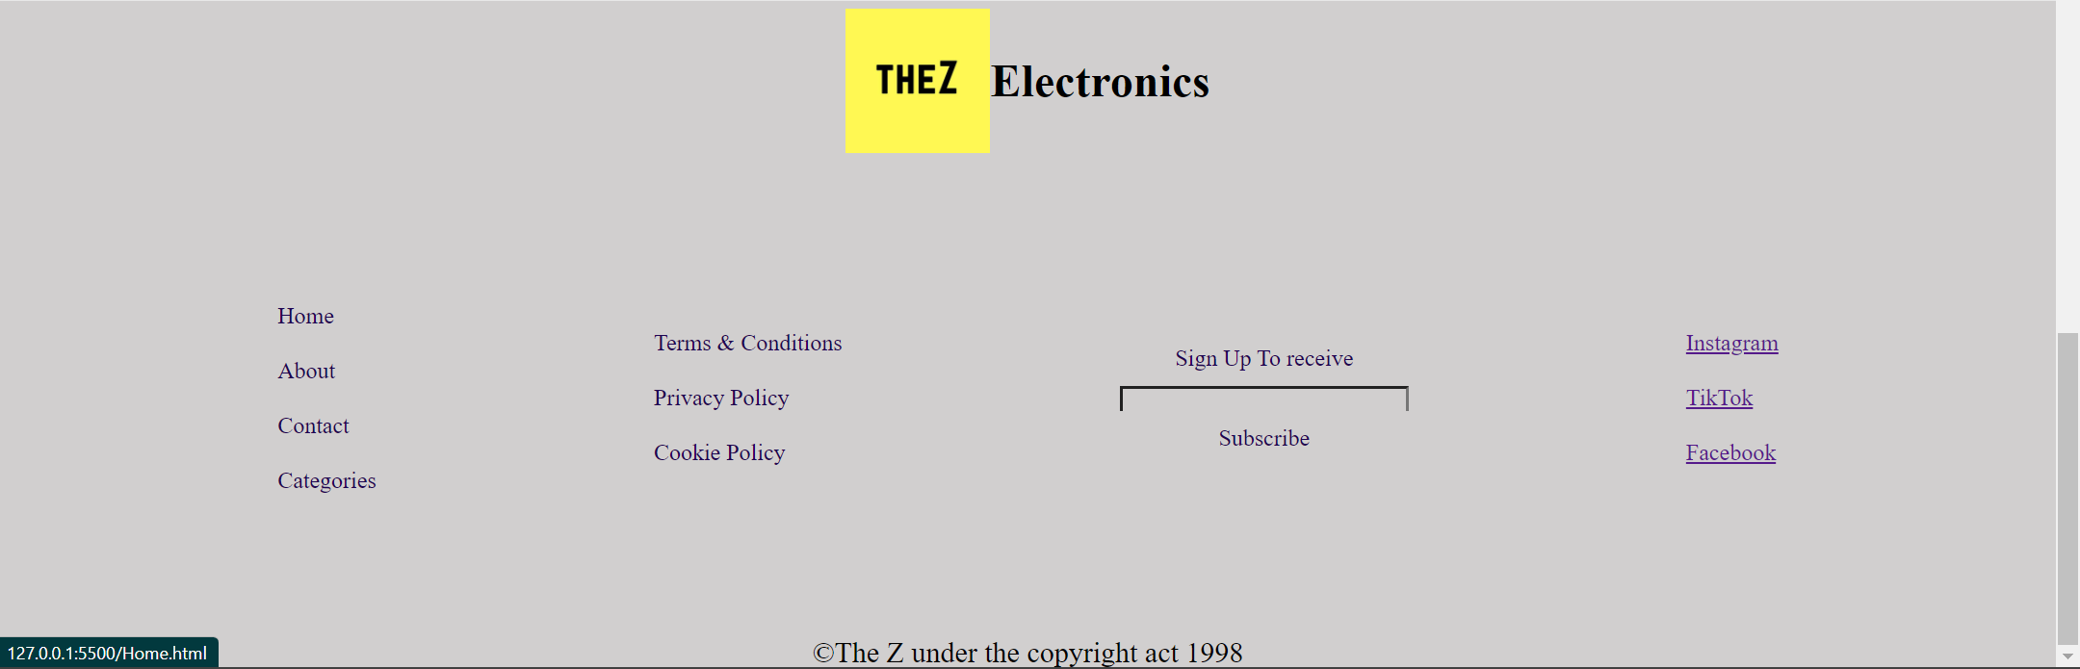

In the last we have the **FOOTER** of the website which consist of copyright notice, social media icons, option for subscribing to our newsletter through e-mail, link to terms and conditions , Cookies Policy etc.

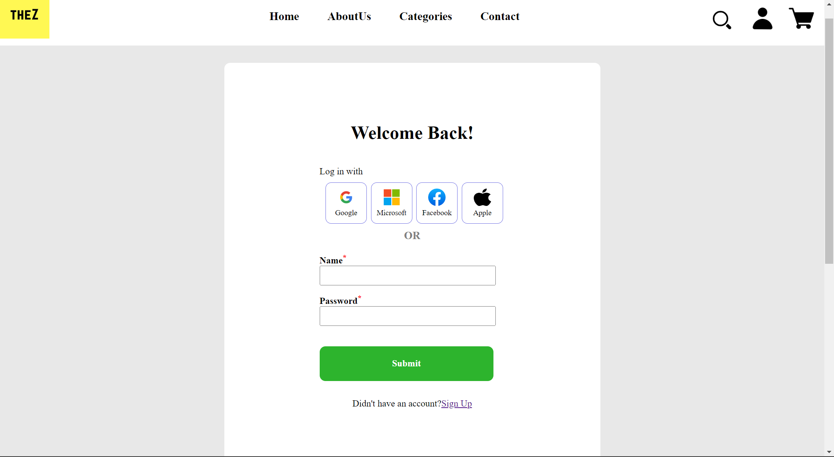

This is the **LOGIN PAGE** of the website where users can Login to their “THEZ” account by using their e-mail id and password. The users can also Login using Google, Facebook, Microsoft, Apple. Also if a user doesn’t have an account in “THEZ”, then the user can sign up by clicking on “CLICK HERE” below the Login Button which will land the user to the **SIGN UP PAGE**.

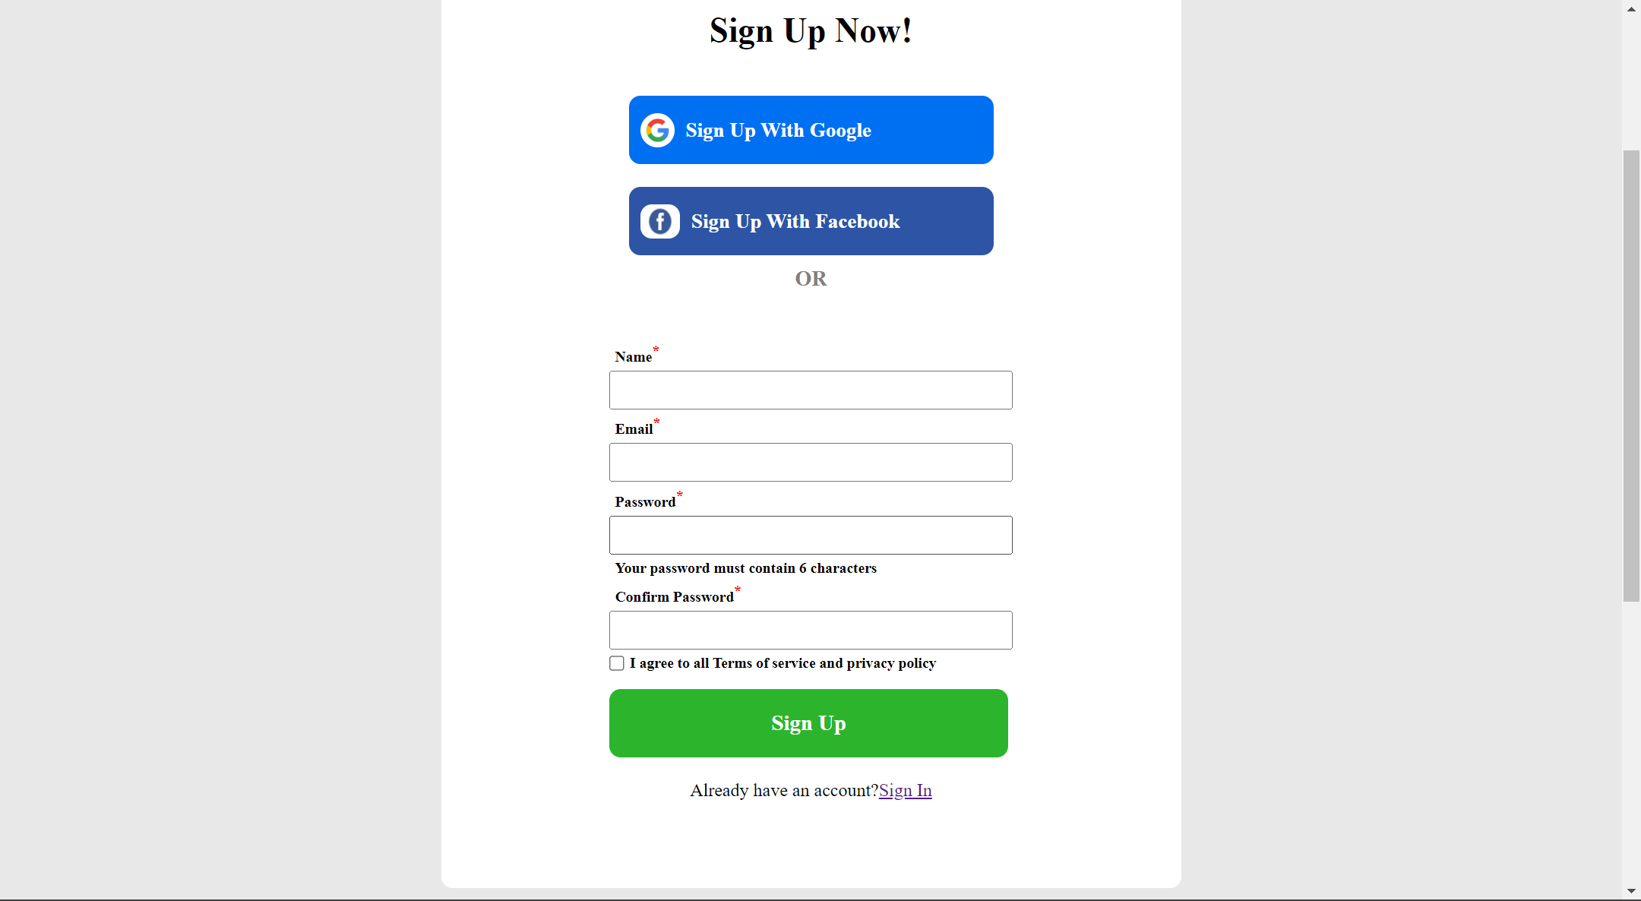

This is the **SIGN UP PAGE** of the website where users can register themselves on “THEZ” by providing us with their personal details such as first name, last name, e-mail id and the password they would like to choose for their account. The users can also register via their Google and Facebook accounts.

Also the user can return to the **LOGIN PAGE** by clicking on “Already? Have an account? Sign In” option below the Sign Up button.

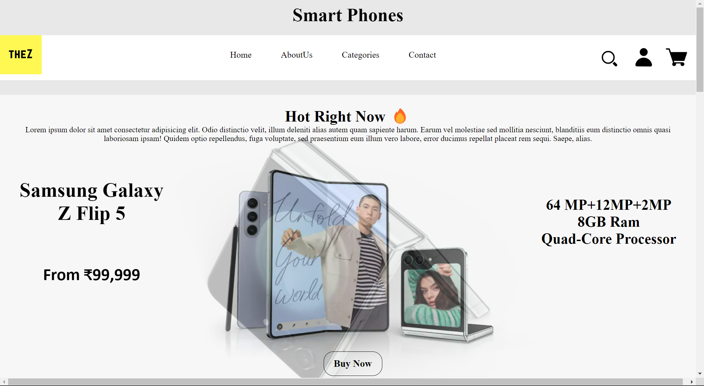

This is **Smart Phone** page in category where the products have been sorted for Smart Phones only .Also the page contains smart phones category if they want to buy by brands like Samsung , MI, Realme, etc. The user can even get the list of the products available in a specific size. Buy now is provided for the poster that is trending.

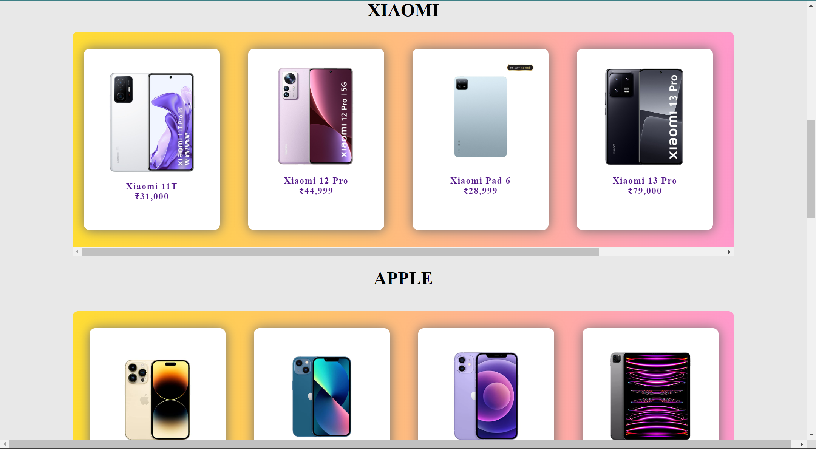

Below are the Screenshots of **laptop category** page

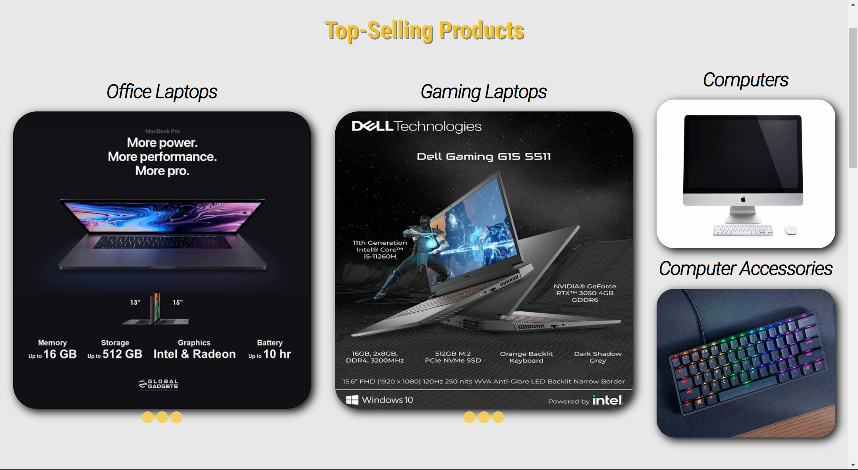

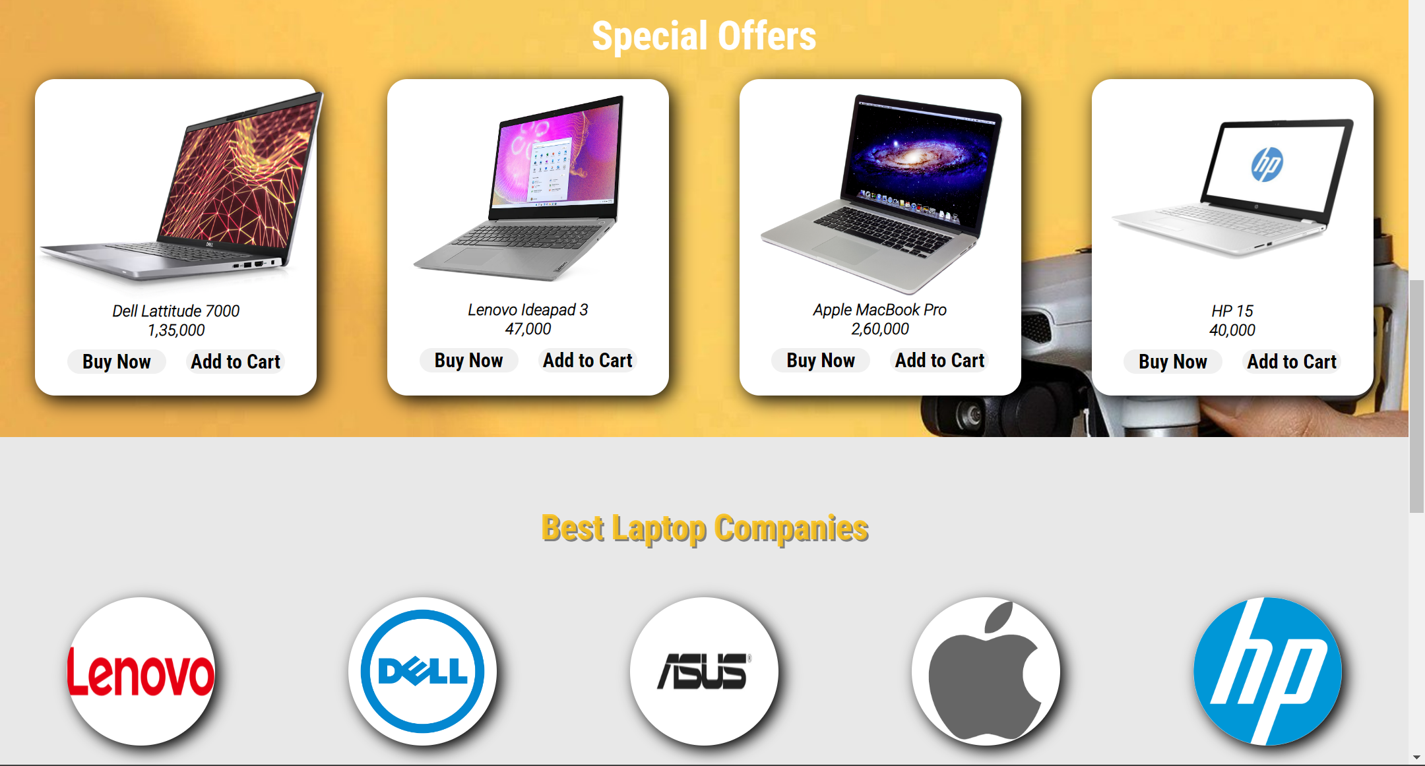

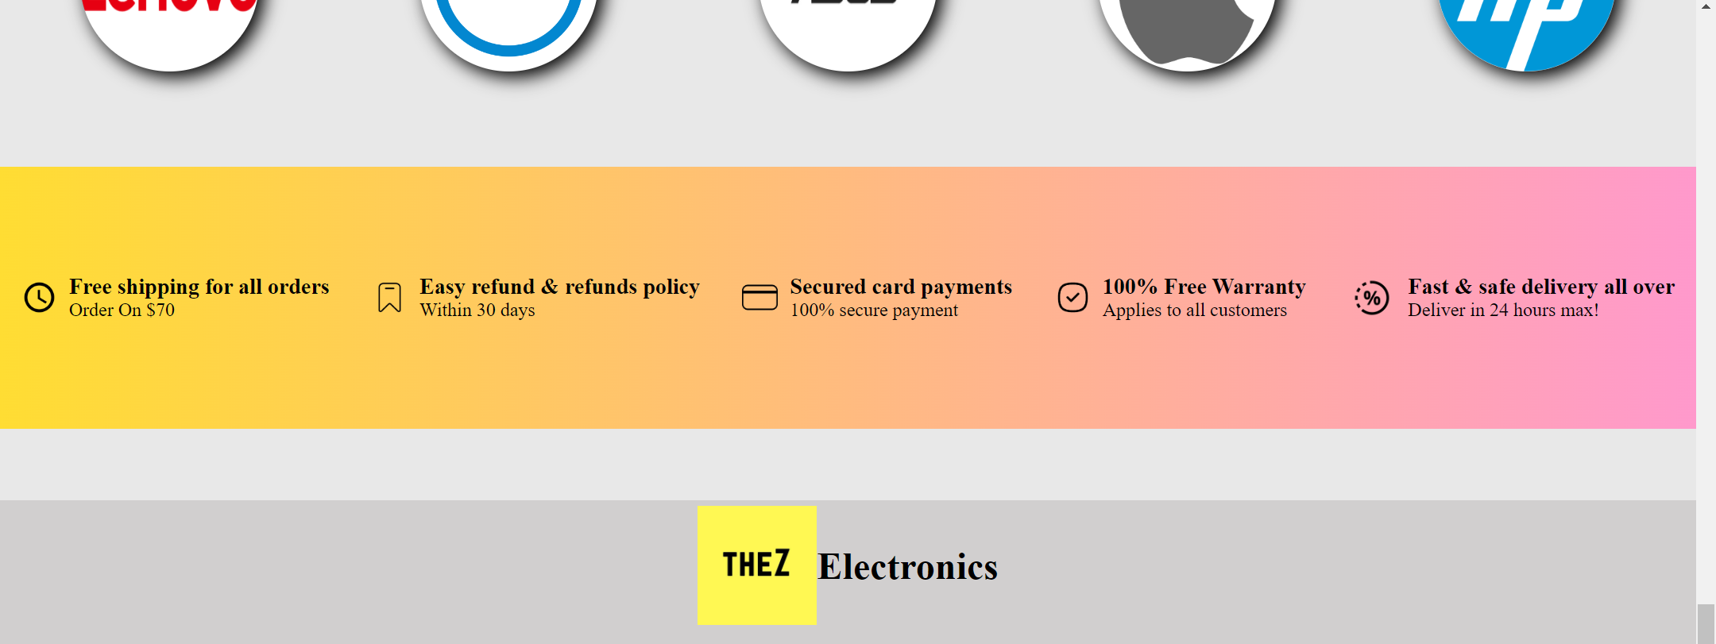

Below are Screenshots for **TV category** page

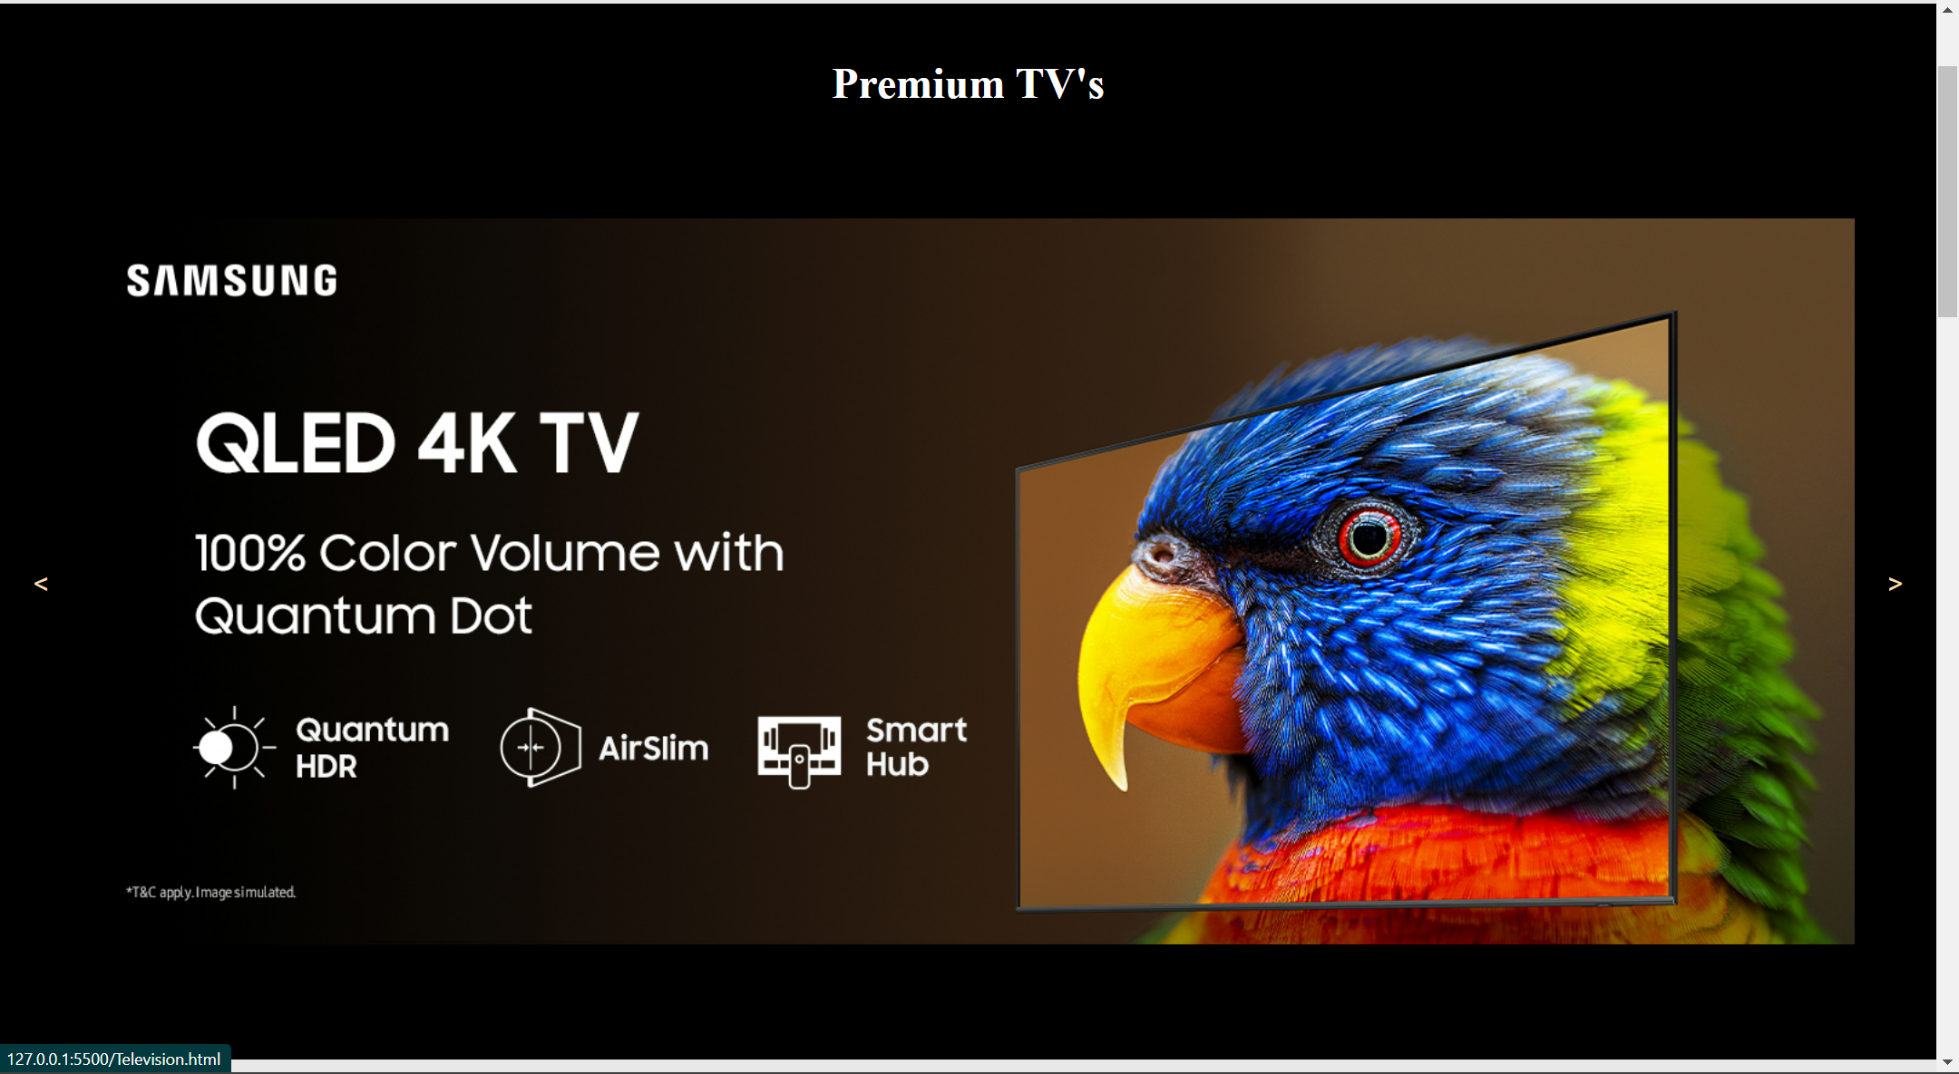

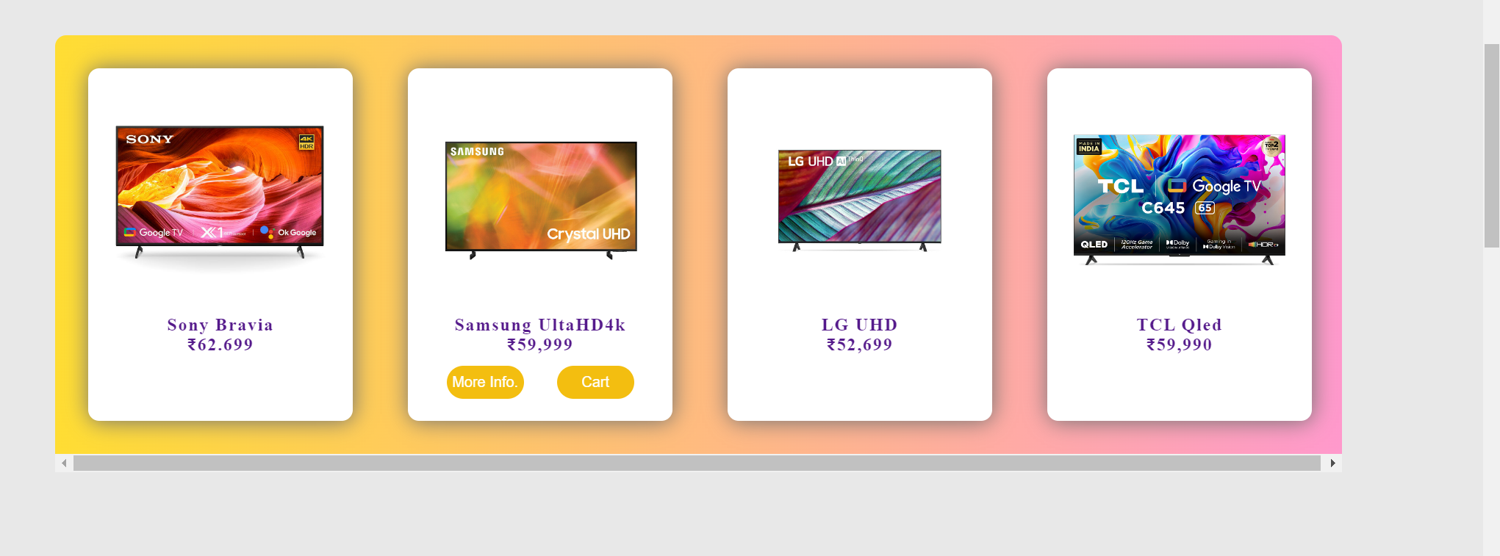

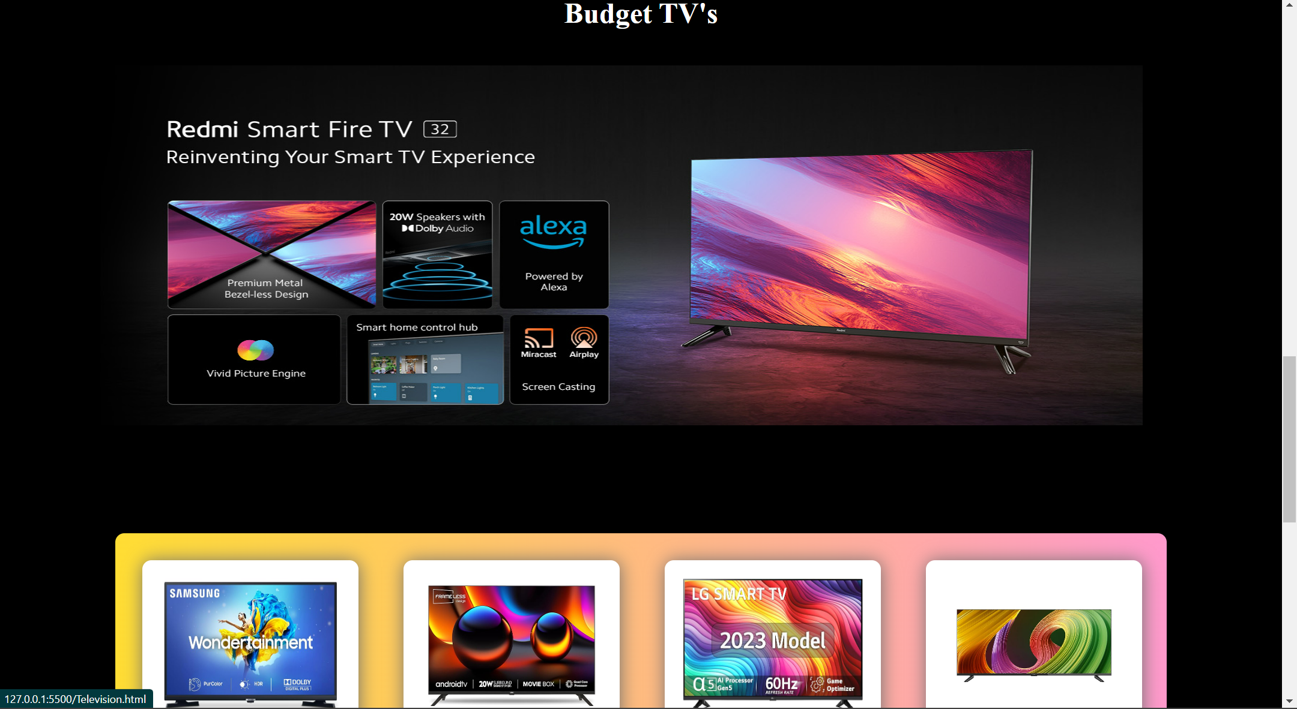

Below is **SMART WATCH** **PAGE** where the latest products on our website have been listed.

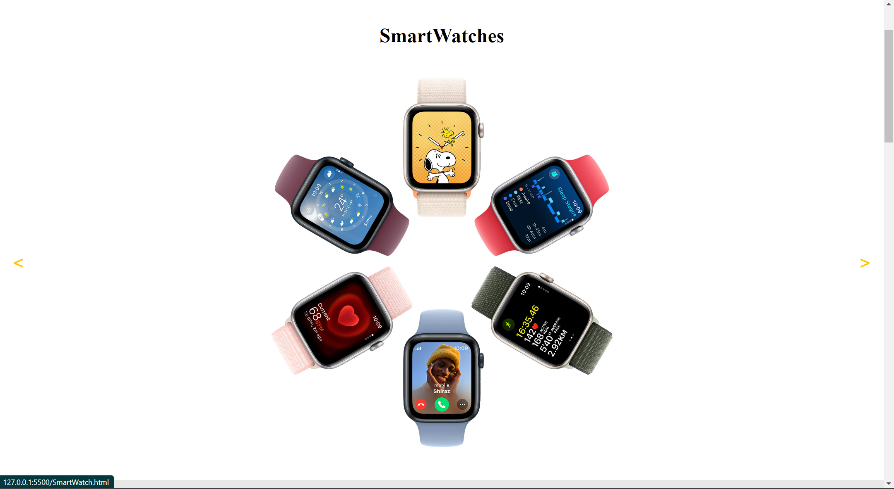

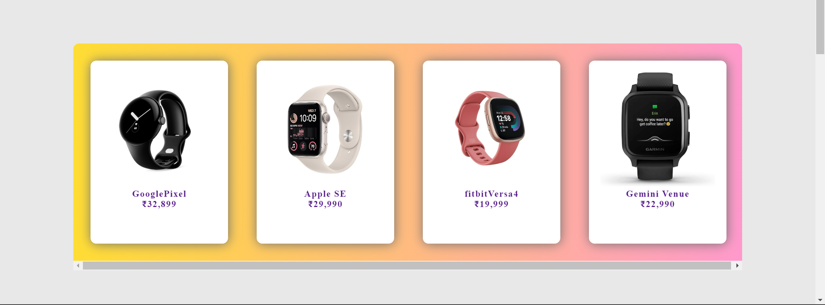

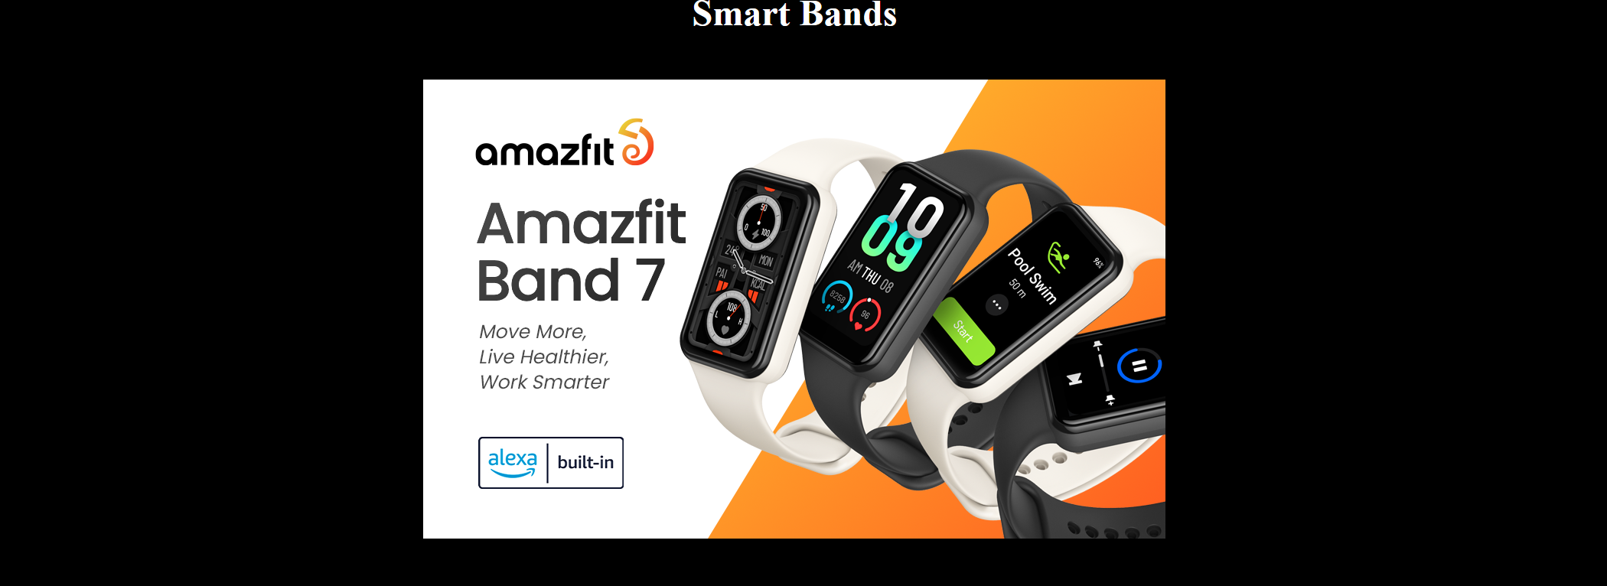

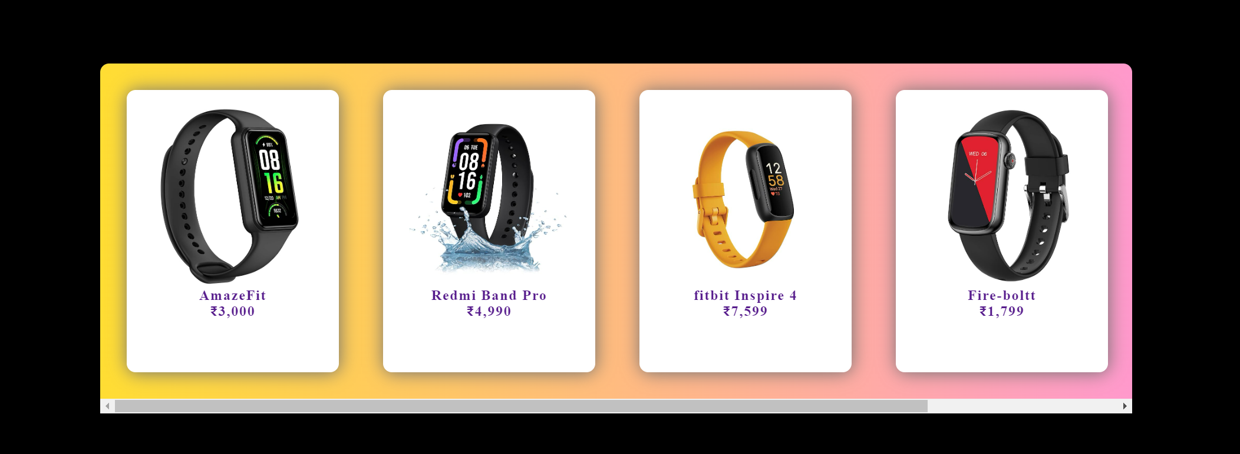

The navigation panel also has an option named as “BRANDS” which on clicking lands the user to a page where all the brands our website serves have been listed.

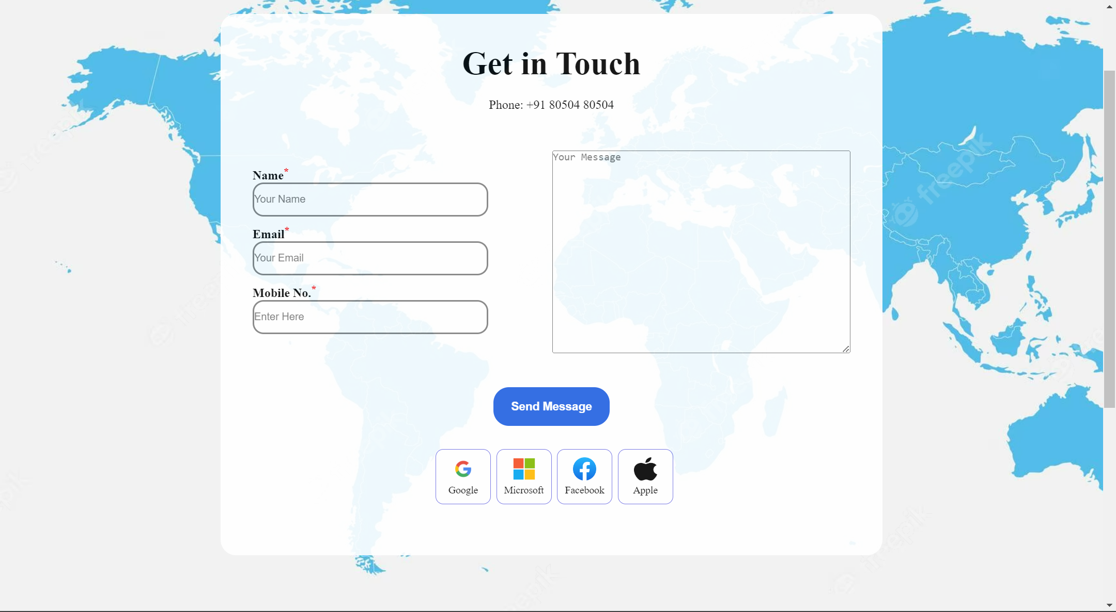

This is the **CONTACT US** page which consist of a form, which can be filled by the user with name, email ,Mobile No., and Feedback message.

About Us Page-

Below are Screenshots for the **ABOUT US PAGE**

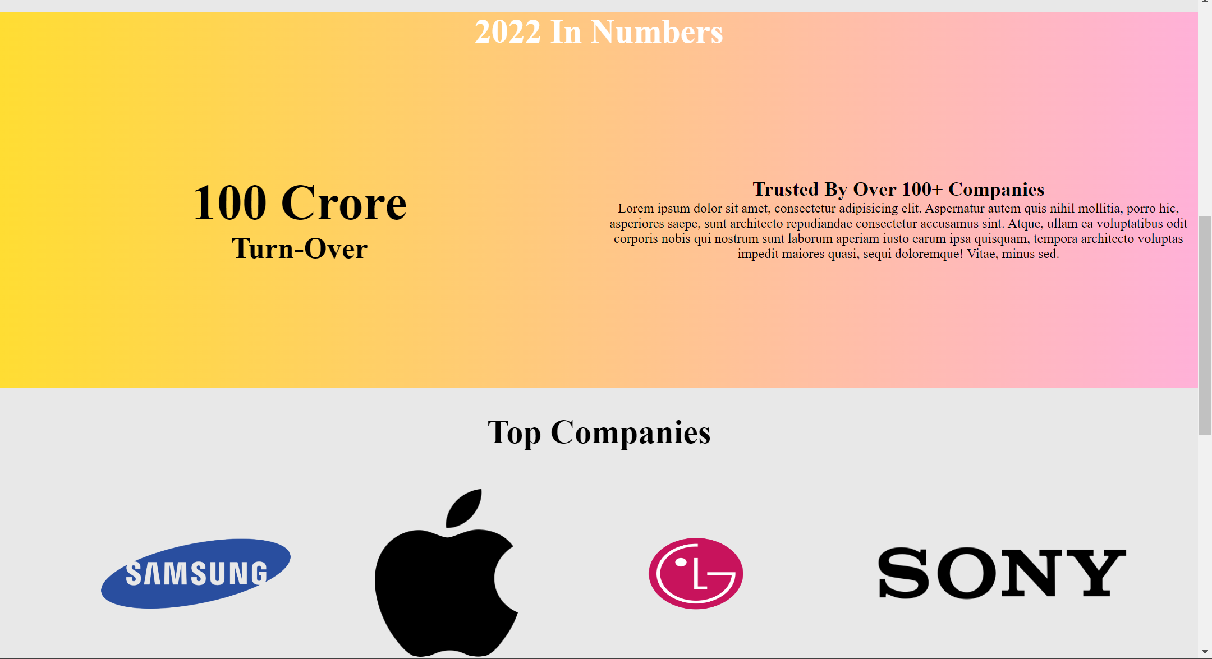

About Us page include information about company about workers etc. It also tells about turn over and top companies which invest in out website and our interested in partnering up.

**HEADPHONE PAGE-**

It includes headphones and earphones and are mostly bought by young generation.

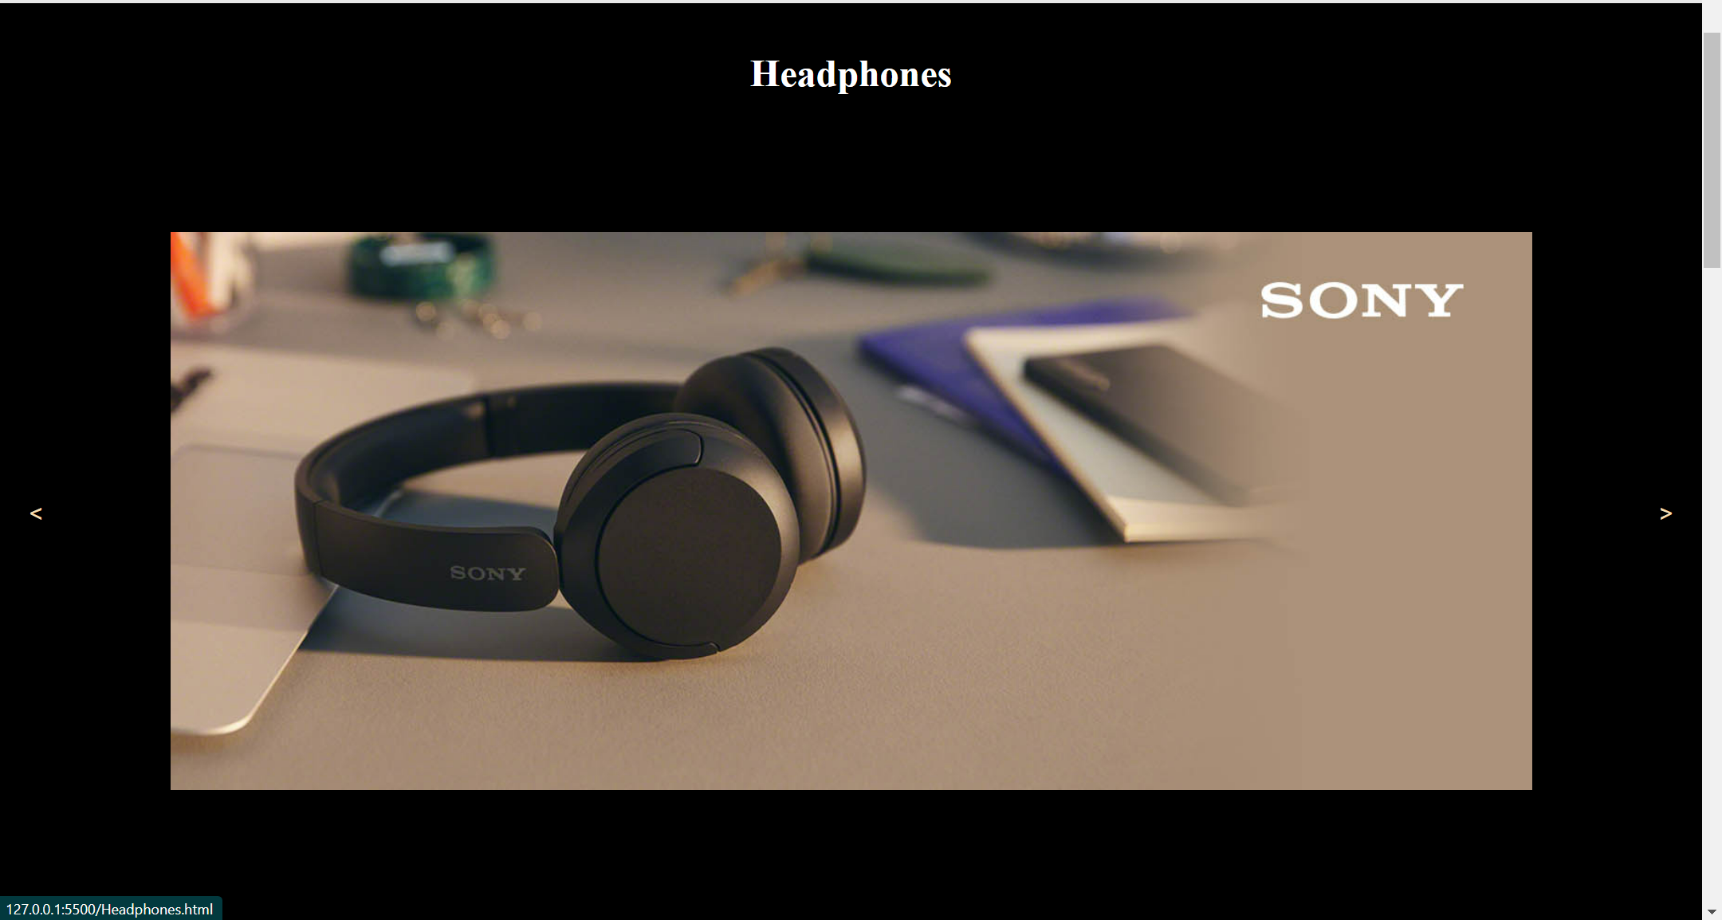

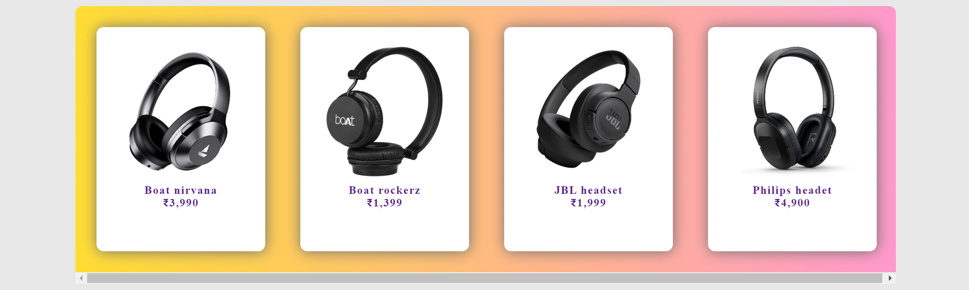

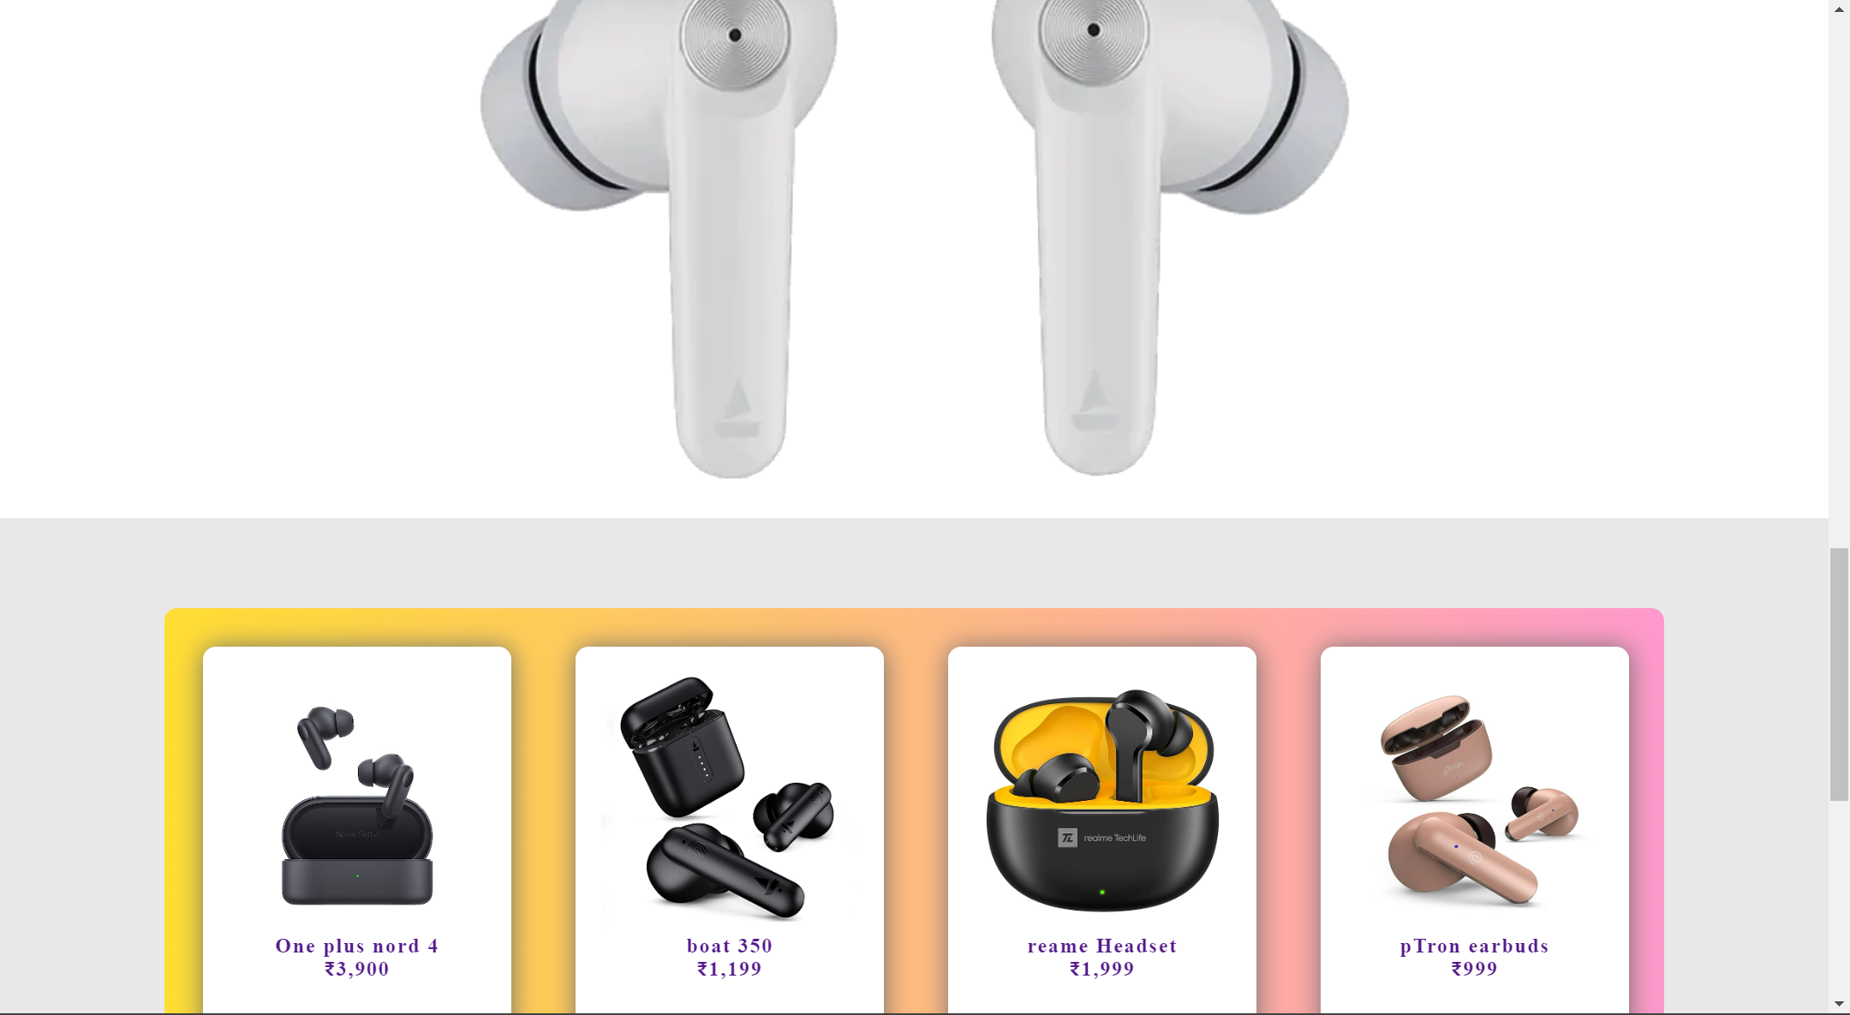

**REFRIGERATOR PAGE-**

This is the refrigerator page anyone who wants to buy refrigerator can buy from here of any brand. 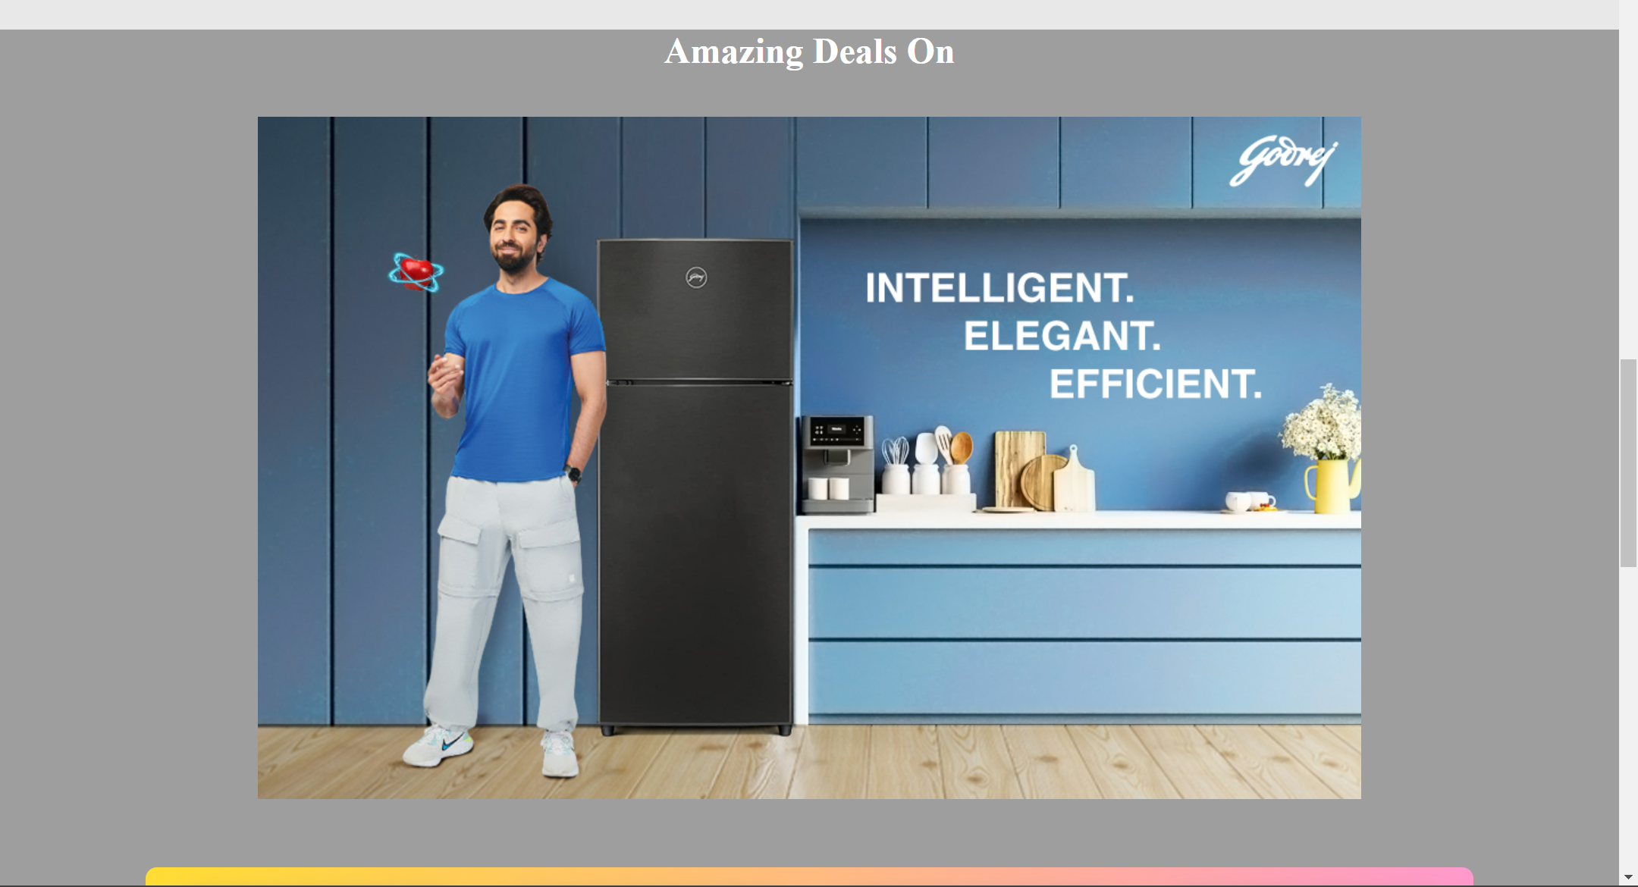

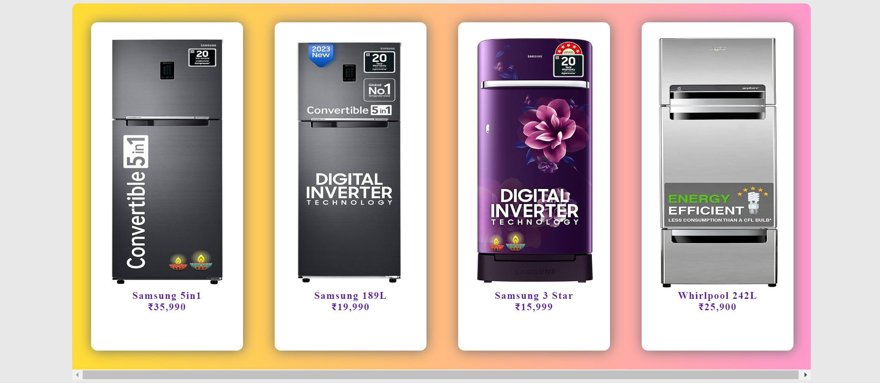

**WASHING MACHINE-**

This is the washing machine page it consists of variety of washing machines dryers, Washer dryers, Front-loading etc.

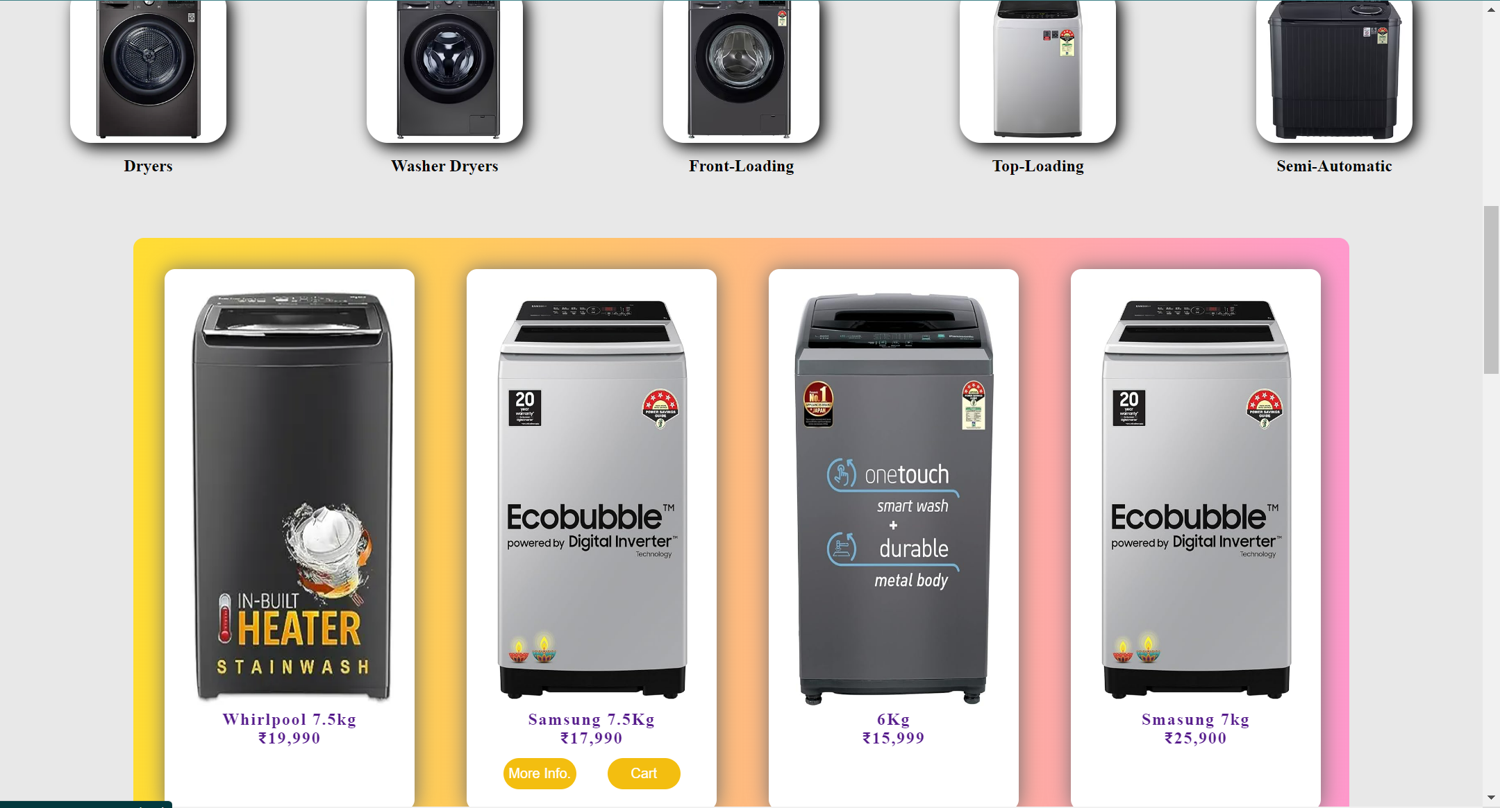

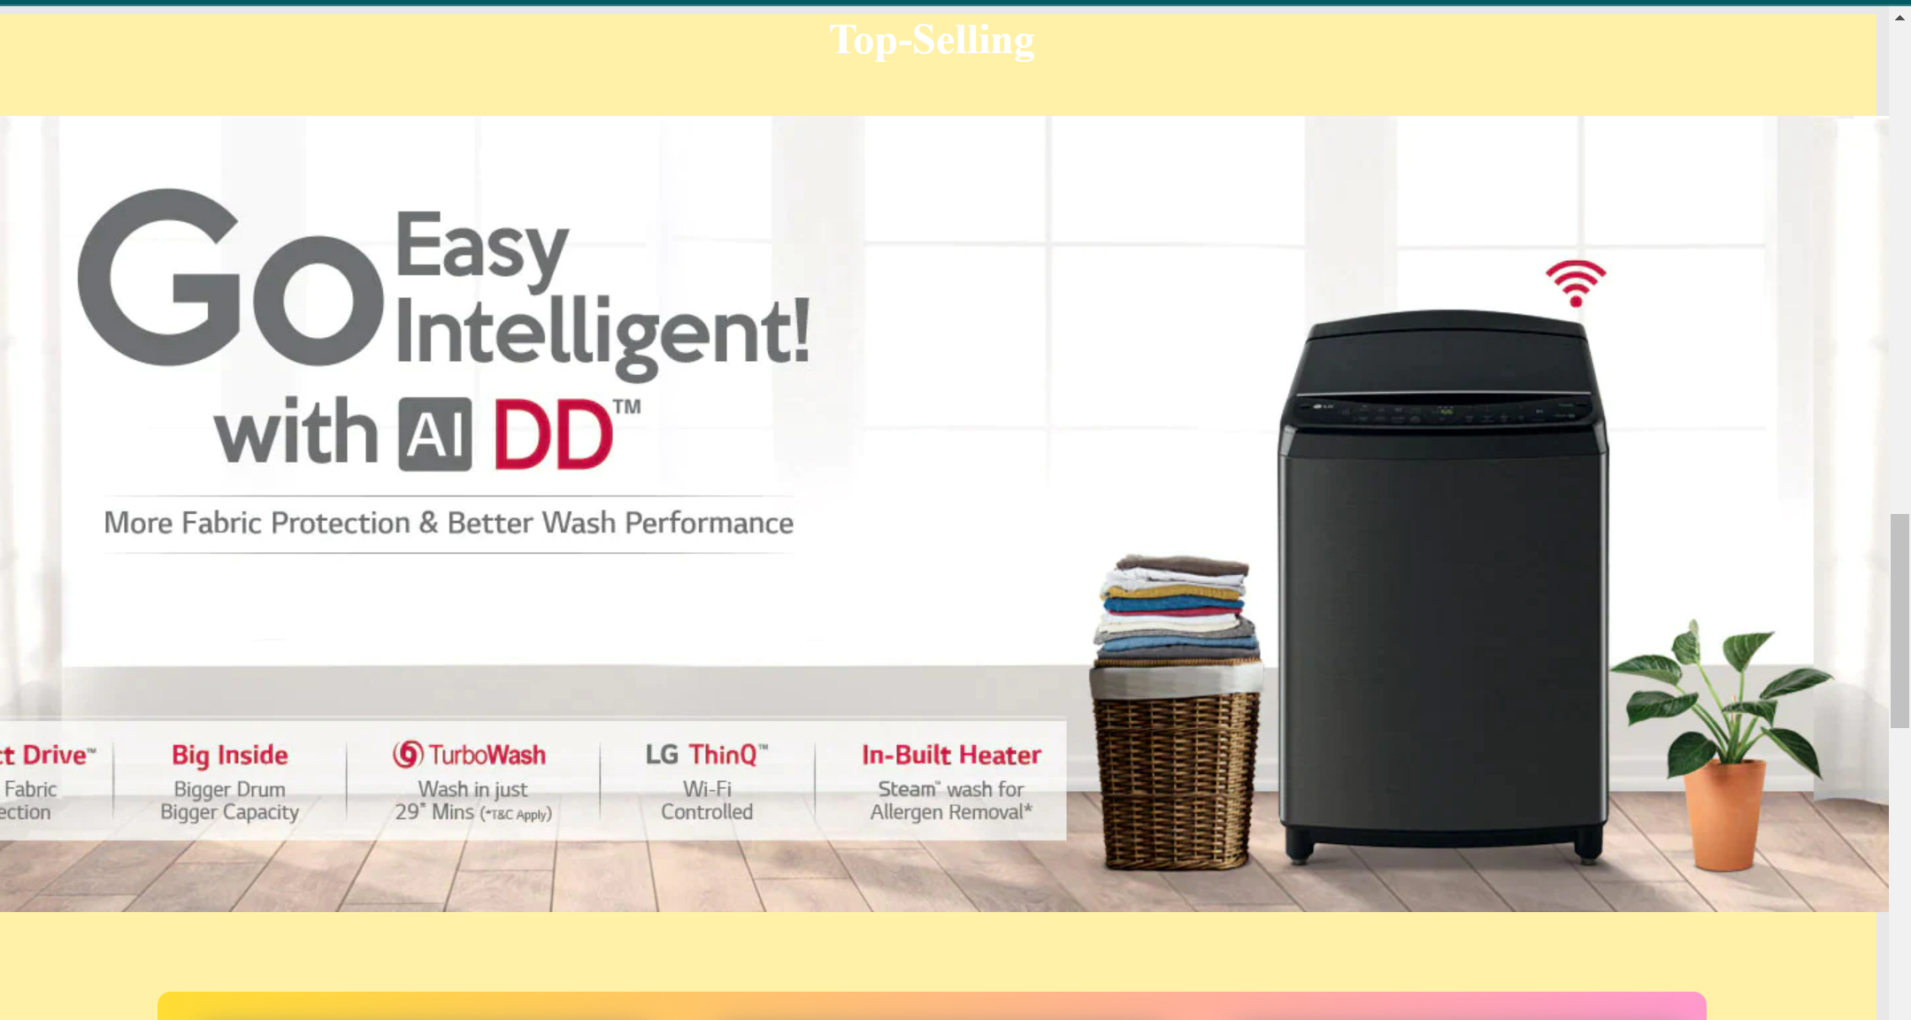

**PRODUCT PAGE –**

This is product page which includes information about specific product.

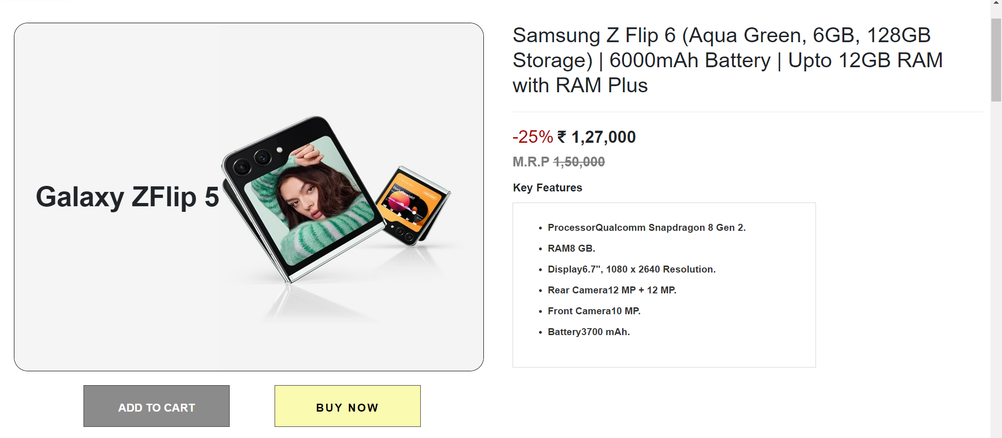

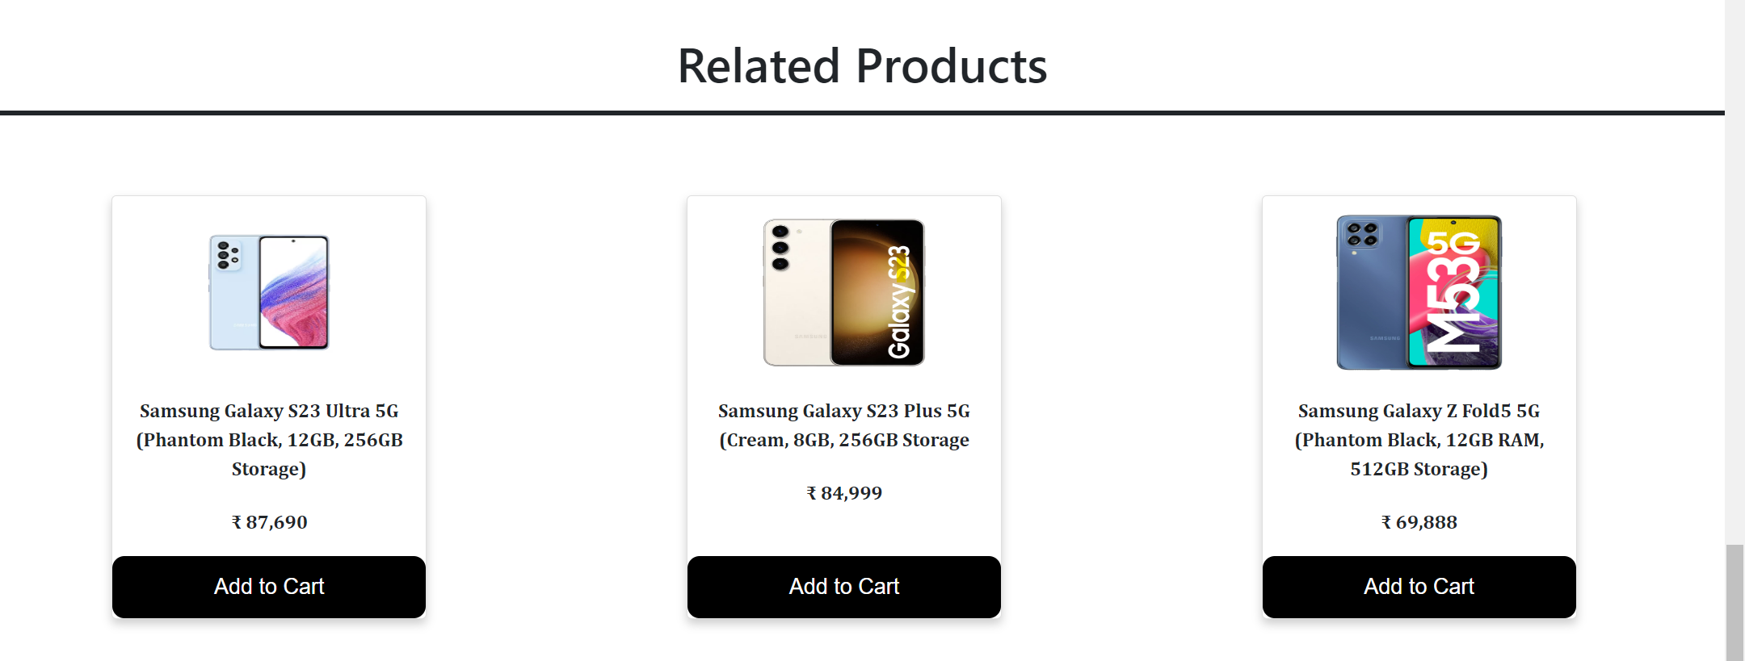

**CART PAGE-**

This page contains products selected by users.

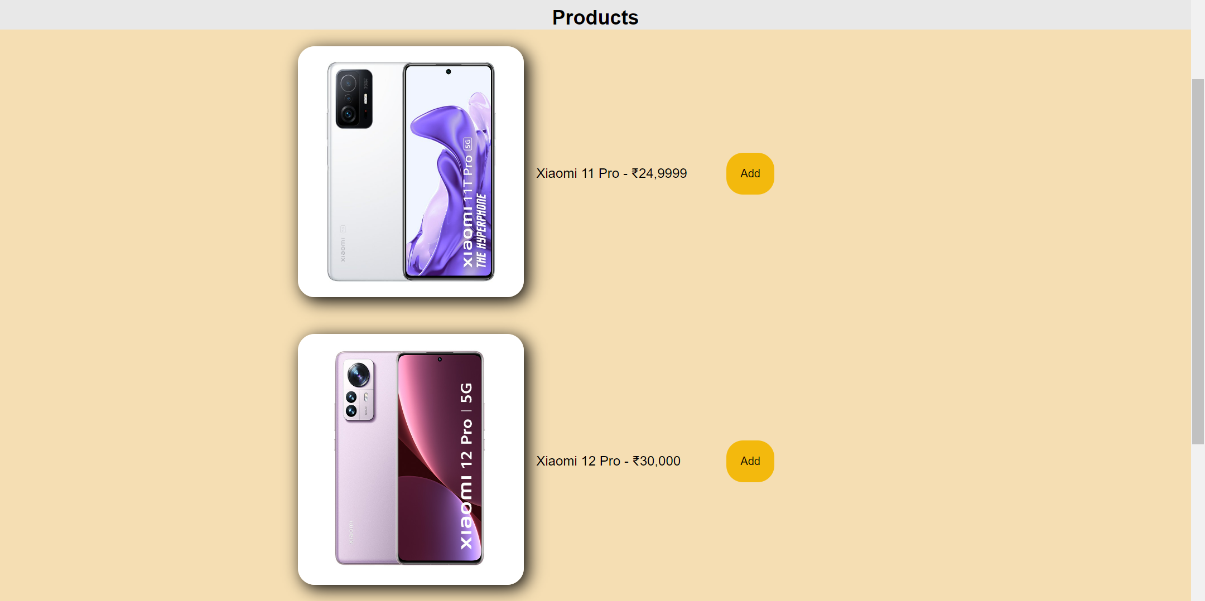



This is **PAYMENT GATEWAY PAGE**

The Card details are entered by the user and the payment will be successful. If this page is submitted without entering anything then it would show invalid input and the user has to enter the details in order to complete the order.

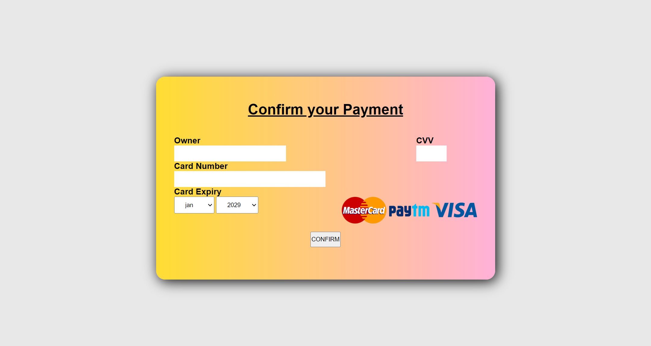

This is **PRODUCT DETAILS PAGE** of the website where every detail of a product is mentioned like the price, product type(men or women), brand, product name, available sizes, manufacturer details, origin, article code are given.

After then there is a section where **PRODUCTS YOU MAY ALSO LIKE** are listed.